Standard, iBeacon System Specification

Rev Date: 02/04/2015

Origination Date: 02/04/2015

Revision Num: v1.0

Author: Max Ding

1. Introduction
iBeacon system includes user APP(Android and iOS), management utility(security) and data base management.

2. Requirement
2.1 Client

2.1.1 Login function
2.1.1.1 Login page
There are 2 input text areas firstly. (帐号, 密码)
There is a checkbox called “Remember me”. (记住密码)
There is a button called “Login”. (登录)
There are two links called “Registration” and “Forget password”. (注册，忘记密码)
Note：针对内部员工，系统默认已开通帐号，用户名和密码都为工号。
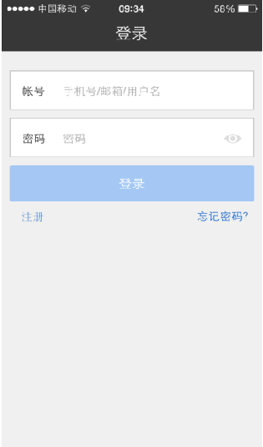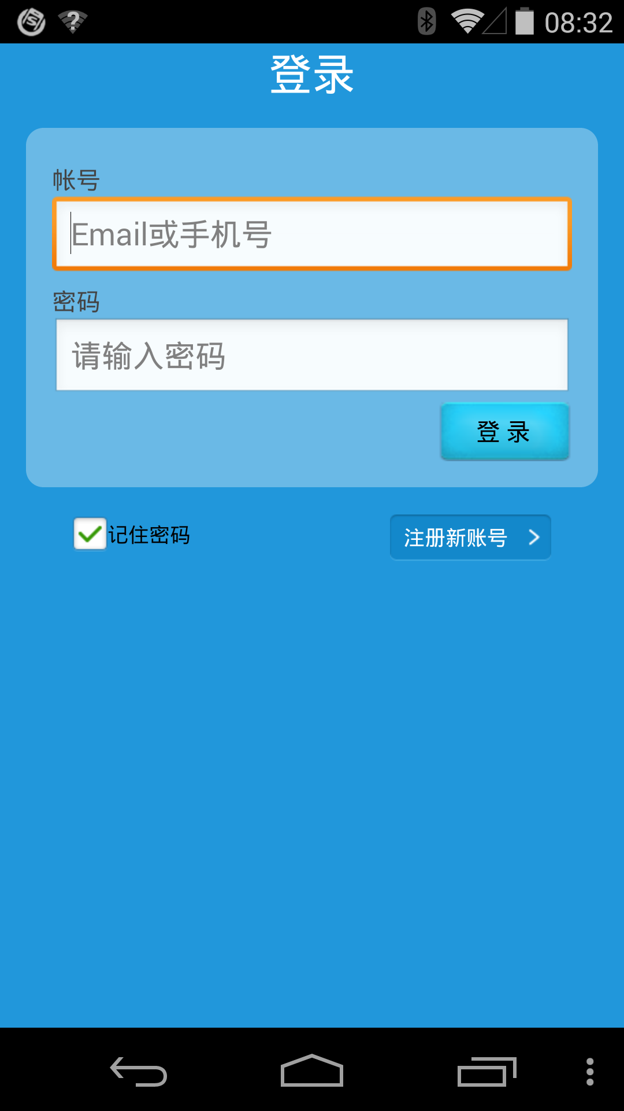

2.1.1.2 Registration page
There are 5 input text areas. (帐号, 密码, 姓名/昵称, 手机号，邮箱)
There is a button called “Register”. (注册)
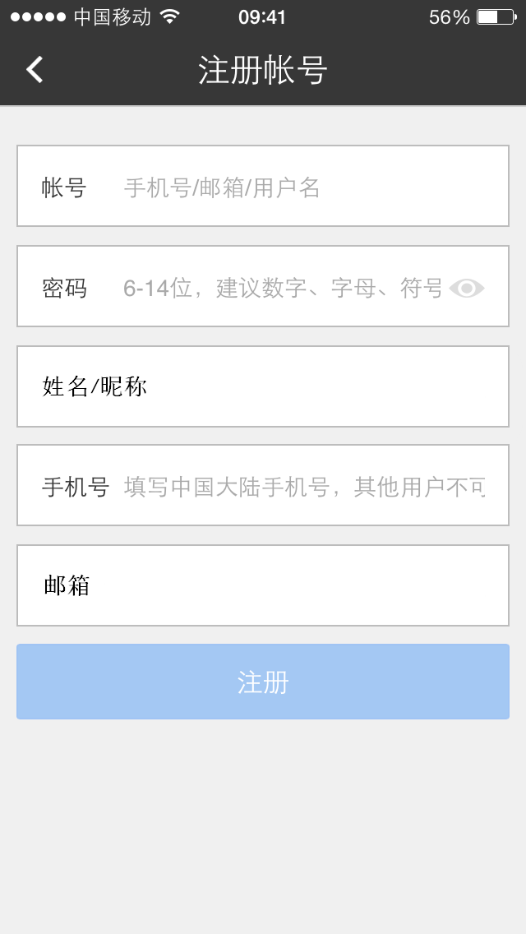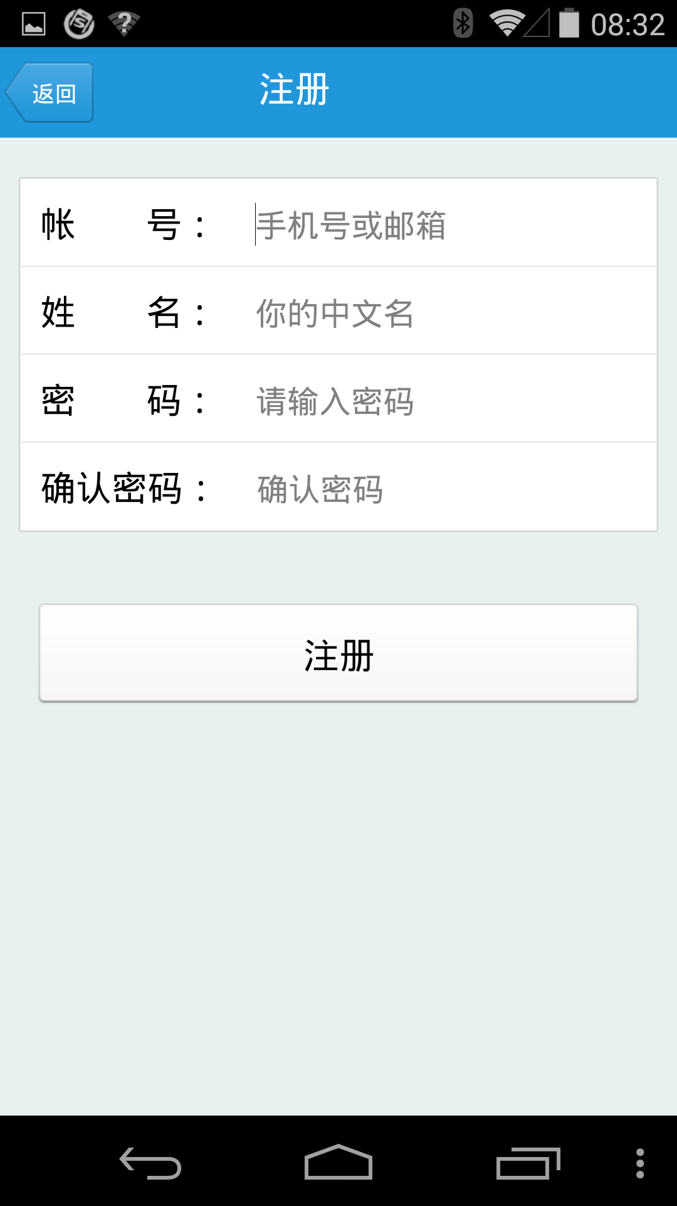

2.1.1.3 Forget password page
Input the email address, and then server will find the related account and send the user id and password to the email address.
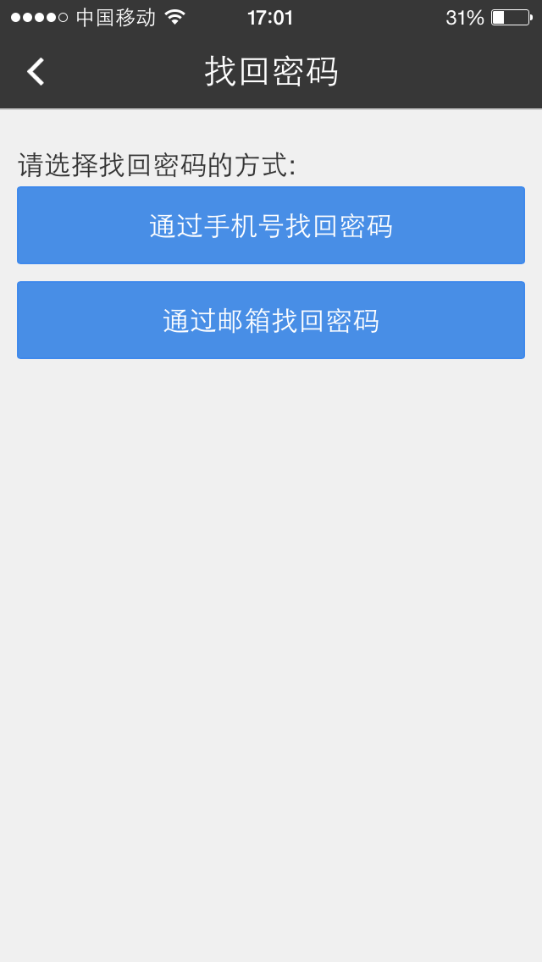

2.1.2 Menu
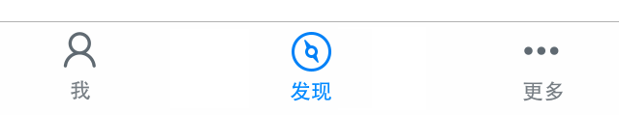

2.1.3 Self Location
地图为PNG格式图片
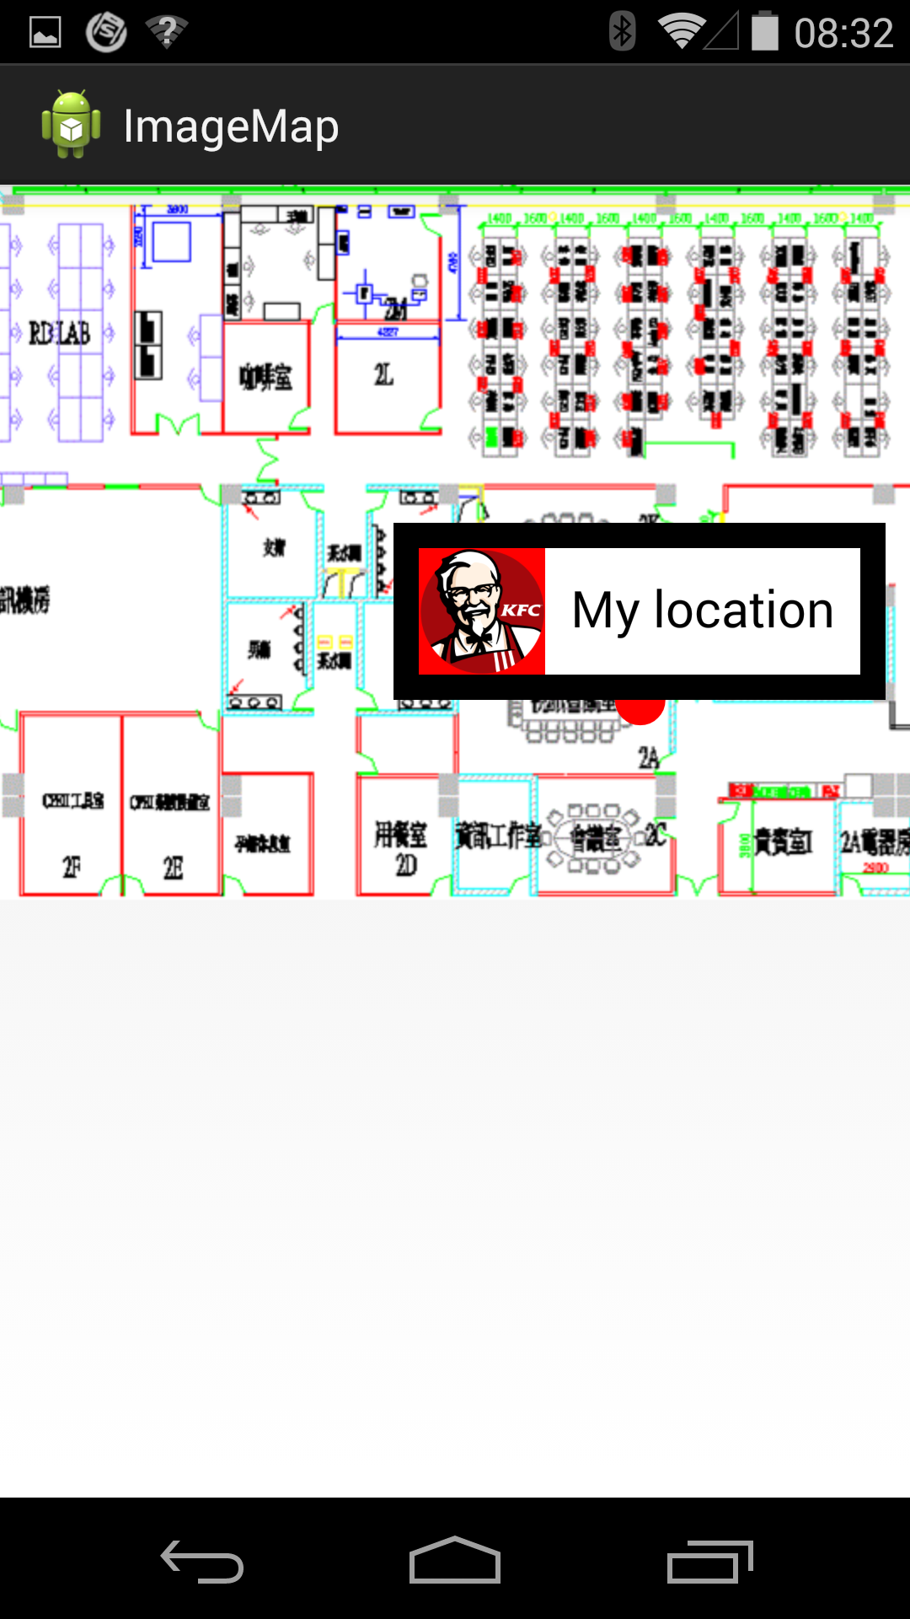

2.1.4 Finding

2.2 Server
Server IP
Internet: 61.129.93.20
Company network: 10.116.57.136
2.3 Communication protocol between client and server
2.3.1 Definition of all items:
- “uid” --- User’s account name. It is also called user id, and it’s unique in data base. It requires 6 to 15 ASCII printable characters (i.e. ASCII 0x21 ~ 0x7E).
- “password” --- Password of the account. It requires 6 to 15 ASCII printable characters (i.e. ASCII 0x21 ~ 0x7E).
- “name” --- User’s real/nick name. It requires 1 to 15 unicode characters from UI. We will transform them into UTF8 format. The UTF8 strings length is limited as 63 bytes. So server can reserve 63 bytes in data base.
- “gender” --- User’s sex gender, should be “male” or “female”.
- “phone” --- User’s mobile phone number. It can be used to password recovery later (send short message to user). It requires 11 digits.
- “email” --- User’s email address. It can be used to password recovery later (send email to user). It requires 3 to 48 ASCII printable characters (i.e. ASCII 0x21 ~ 0x7E). And the email format MUST obey following rules:
- There has to be one and only one 'at' sign ('@') in the address.
- Only printable characters are allowed, i.e. ASCII 0x21 ~ 0x7E.
- There has to be at least one character before the @.
- There has to be at least one non-dot character after the last dot character.
- For each dot character after the @, there has to be at least one non-dot and non-at character before it.
- There has to be at least one dot character ('.') after the @.
- “mapurl” --- The url address to get the map. E.g.
http://xxx.xxx.xxx.xxx/xpos/Beacon/sh_lab_1001_20.png ---> 1001 is the map site id, 20 is the version number of the map.

2.3.2 Register API
HTTP POST http://xxx.xxx.xxx.xxx/xtalball/Beacon/Services/register
Parameters: uid=xxx&password=xxxx&name=xxx&gender=xxx&phone=xxxx&email=xxxx
Return value:
Success: {“result”:“pass”}
Fail: {“result”:“fail”,“error_code”:“xxx”}
ID | ERROR_CODE | DESCRIPTION
1 | 0101 | Format of user id not correct.
2 | 0102 | Format of name not correct.
3 | 0103 | Format of password not correct.
4 | 0110 | User id has already been registered.
5 | 0111 | Server database operation fail.

2.3.2.1 Register By Phone API
HTTP POST http://xxx.xxx.xxx.xxx/xtalball/Beacon/Services/registerByPhone
Parameters: uid=xxx&password=xxxx&name=xxx&gender=xxx&phone=xxxx&email=xxxx&captcha=xxxx
Return value:
Success: {“result”:“pass”}
Fail: {“result”:“fail”,“error_code”:“xxx”}
ID | ERROR_CODE | DESCRIPTION
1 | 0101 | Format of user id not correct.
2 | 0102 | Format of name not correct.
3 | 0103 | Format of password not correct.
4 | 0110 | User id has already been registered.
5 | 0111 | Server database operation fail.
6 | 0112 | Verification code error
7 | 0113 | Verification Code timeout

2.3.3 Login API
HTTP POST http://xxx.xxx.xxx.xxx/xtalball/Beacon/Services/login
Parameters: uid=xxxx&password=xxxx&sysinfo=xxx
Return value:
Success: {“result”:“pass”,“PHPSESSID”:“xxx”}
Fail: {“result”:“fail”,“error_code”:“xxx”}
After that, client will save the session id.
ID | ERROR_CODE | DESCRIPTION
1 | 0201 | User id not exists.
2 | 0202 | Password not correct.

2.3.4 Change password API

HTTP POST http://xxx.xxx.xxx.xxx/xtalball/Beacon/Services/changepassword
Parameters: uid=xxxx&password=xxxx&newpassword =xxxx
Return value:
Success: {“result”:“pass”}
Fail: {“result”:“fail”,“error_code”:“xxx”}
ID | ERROR_CODE | DESCRIPTION
1 | 0301 | New password format not correct.
2 | 0302 | User authentication fail.

2.3.5 Change info API

HTTP POST http://xxx.xxx.xxx.xxx/xtalball/Beacon/Services/changeuserinfo
Cookie: add the session id in cookie field

Parameters: name=xxx&gender=xx&phone=xxxx&email=xxxx
Return value:
Success: {“result”:“pass”}
Fail: {“result”:“fail”,“error_code”:“xxx”}
ID | ERROR_CODE | DESCRIPTION
1 | 0401 | User not login.
2 | 0402 | Format of name not correct.

2.3.6 Query info API
HTTP POST http://xxx.xxx.xxx.xxx/xtalball/Beacon/Services/queryuserinfo

Cookie: add the session id in cookie field
Parameters:
Return value:
Success:
{"result":"pass","userinfo":{"uid":xxx,"name":xx,"gender":xx,"phone":xx,"email":xx}}
Fail: {“result”:“fail”,“error_code”:“xxx”}
ID | ERROR_CODE | DESCRIPTION
1 | 0501 | User not login.
2 | 0502 | Database operation fail.

2.3.7 Query map API
HTTP POST http://xxx.xxx.xxx.xxx/xtalball/Beacon/Services/querymap
Cookie: add the session id in cookie field
Parameters: devicemac=xxxx
Return value:
Success: {“result”:“pass”,"siteid":xxx,"version":xxx,"description":xx,"mapurl":xxx}
Fail: {“result”:“fail”,“error_code”:“xxx”}
ID | ERROR_CODE | DESCRIPTION
1 | 0601 | User not login.
2 | 0602 | Can not find map info or database operation fail.

2.3.8 Query position API (by MAC)

HTTP POST http://xxx.xxx.xxx.xxx/xtalball/Beacon/Services/querypositionbymac
Cookie: add the session id in cookie field
Parameters: devicemac=xxxx
Return value:
Success: {“result”:“pass”,“position”:{“mapid”:“xxx”,“x”:“xxx”,“y”:“xxx”} }
Fail: {“result”:“fail”,“error_code”:“xxx”}
Optional info for “position”: {"name":"device sn","info":"lab","address":"00:11:22:33:44:55"}
ID | ERROR_CODE | DESCRIPTION
1 | 0701 | User not login.
2 | 0702 | Can not find position info or database operation fail.

2.3.9 Query position API (by uid)
HTTP POST http://xxx.xxx.xxx.xxx/xtalball/Beacon/Services/querypositionbyuid
Cookie: add the session id in cookie field
Parameters: uid=xxxx
Return value:
Success: {“result”:“pass”,“position”:{“mapid”:“xxx”,“x”:“xxx”,“y”:“xxx”} }
Fail: {“result”:“fail”,“error_code”:“xxx”}
ID | ERROR_CODE | DESCRIPTION
1 | 0801 | User not login.
2 | 0802 | Can not find position info or database operation fail.

2.3.10 Query position API (by name)
HTTP POST http://xxx.xxx.xxx.xxx/xtalball/Beacon/Services/querypositionbyname
Cookie: add the session id in cookie field
Parameters: name=xxxx
Return value:
Success:{"result":"pass","positions":[{"uid":"xxx","position":null},{"uid":"testuser","position":{"mapid":xxx,"x":xxx,"y":xxx}}]}
Fail: {“result”:“fail”,“error_code”:“xxx”}
ID | ERROR_CODE | DESCRIPTION
1 | 0901 | User not login.
2 | 0902 | Can not find name in database or database operation fail.

2.3.11 Get map API
HTTP GET mapurl
Cookie: add the session id in cookie field
Parameters: none
Return value: return the map file.

2.3.12 Post track data API (batch post)
HTTP POST http://xxx.xxx.xxx.xxx/xtalball/Beacon/Services/posttrack
Cookie: add the session id in cookie field
Parameters: postdata=xxx,use json format
postdata={
“posttime”:” 2015-02-06 16:00:00”,

"track":[
{" localtime ":"2015-02-06 14:00:00","devicemac":"00:11:22:33:44:55"},
{" localtime ":"2015-02-06 14:01:01","devicemac":"00:11:22:33:44:66"},
{" localtime ":"2015-02-06 14:02:02","devicemac":"00:11:22:33:44:77"},

{" localtime ":"2015-02-06 14:03:00","devicemac":"00:11:22:33:44:88"}
]
}
Return value:
Success: {“result”:“pass”}
Fail: {“result”:“fail”,“error_code”:“xxx”}
ID | ERROR_CODE | DESCRIPTION
1 | 1001 | User not login.
2 | 1002 | Database operation fail.

2.3.13 Post track data API (single post)
HTTP POST http://xxx.xxx.xxx.xxx/xtalball/Beacon/Services/postdata
Cookie: add the session id in cookie field
Parameters: localtime=xxxx&devicemac=xxxx
localtime format sample 2015-02-06 14:00:00
address format sample 00:11:22:33:44:55
Return value:
Success: {"result":"pass","position":{"mapid":"1","x":"100","y":"100"}}
Fail: {“result”:“fail”,“error_code”:“xxx”}
ID | ERROR_CODE | DESCRIPTION
1 | 1101 | User not login.
2 | 1102 | Database operation fail.

2.3.13 Query map API by mapid
HTTP POST http://xxx.xxx.xxx.xxx/xtalball/Beacon/Services/querymapbymapid
Cookie: add the session id in cookie field
Parameters: mapid=xxxx
Return value:
Success: {“result”:“pass”,"siteid":xxx,"version":xxx,"description":xx,"mapurl":xxx}
Fail: {“result”:“fail”,“error_code”:“xxx”}
ID | ERROR_CODE | DESCRIPTION
1 | 1201 | User not login.
2 | 1202 | Can not find map info or database operation fail.

2.3.14 Query position API (by uid or name )
HTTP POST http://xxx.xxx.xxx.xxx/xtalball/Beacon/Services/queryposition
Cookie: add the session id in cookie field
Parameters: key=xxxx
Return value:
Success:{"result":"pass","positions":[{"uid":"xxx","position":null},{"uid":"testuser","position":{"mapid":xxx,"x":xxx,"y":xxx}}]}
Fail: {“result”:“fail”,“error_code”:“xxx”}
ID | ERROR_CODE | DESCRIPTION
1 | 1301 | User not login.
2 | 1302 | Can not find name in database or database operation fail.

2.3.14 Query devices infomation API (by mapid )
HTTP POST http://xxx.xxx.xxx.xxx/xtalball/Beacon/Services/querydevicesbymapid
Cookie: add the session id in cookie field
Parameters: key=mapid
Return value:
Success: {"result":"pass","mapid":xxx,"devices":[{"address":xxx,"mapid":xxx,"x":xxx,"y":xxx,"name":xxx,"info":xxx},{"address":xxx,"mapid":xx,"x":xxx,"y":xxx,"name":xx,"info":xx}]}

Fail: {“result”:“fail”,“error_code”:“xxx”}
ID | ERROR_CODE | DESCRIPTION
1 | 1401 | User not login.
2 | 1402 | Can not find name in database or database operation fail.

2.3.15 Send Verification Code
HTTP POST http://xxx.xxx.xxx.xxx/xtalball/Beacon/Services/getCaptcha
Parameters: phone=xxx
Return value:
Success: {“result”:“pass”}
Fail: {“result”:“fail”,“error_code”:“xxx”}
ID | ERROR_CODE | DESCRIPTION
1 | 1501 | Format of phone number not correct.
2 | 1502 | Send Verification code fail.

